BASIC TACTICS

LOCATE A TARGET BY
SHIFT FROM A KNOWN POINT
061-283-1004

CONDITIONS

Given a map of the target area, binoculars, and a declinated M2 compass. The soldier will have identified a suspected target near a point known by him, to include direction, and the known point is plotted in the fire direction center (FDC). The soldier’s location is plotted on his map.

STANDARDS

Locate the target within 250 meters of the actual location and announce the location within 30 seconds after identification. Express direction to the nearest 10 mils and within 100 mils of actual direction. Express right or left corrections to the nearest 10 meters and range corrections to the nearest 100 meters.

TRAINING AND EVALUATION
Training Information Outline

1. Definitions.
a. Deviation—The distance, in mils or meters, that a target is right or left of a known point; or the distance, in mils or meters, that a round bursts right or left of a target.
b. Lateral shift—The correction, in meters, that the FO sends to the FDC to bring mortar or artillery rounds onto the observer-target (OT) line.
c. Range correction—The correction for range, in meters, that the FO sends to the FDC to hit the target or bracket or creep a mortar or artillery round onto the target.
d. OT factor—The known or estimated distance to a target or known point, expressed in thousands (for example, 2,500 meters is expressed as 2.5), and used to convert the distance between two points from mils to meters (lateral shift).

2. Determine OT direction.
a. Measuring deviation from a known point to the target.
(1) With binoculars. In looking through binoculars, you will see a mil scale, which is used to measure horizontal distance (Figure 1). This scale is divided into 10-mil increments, with 100 mils across the scale. Assume that Hill 905 in Figure 2 is your known point. Measure the deviation from Hill 905 to the target. The deviation is three 10-mil increments, or 30 mils, right of Hill 905.

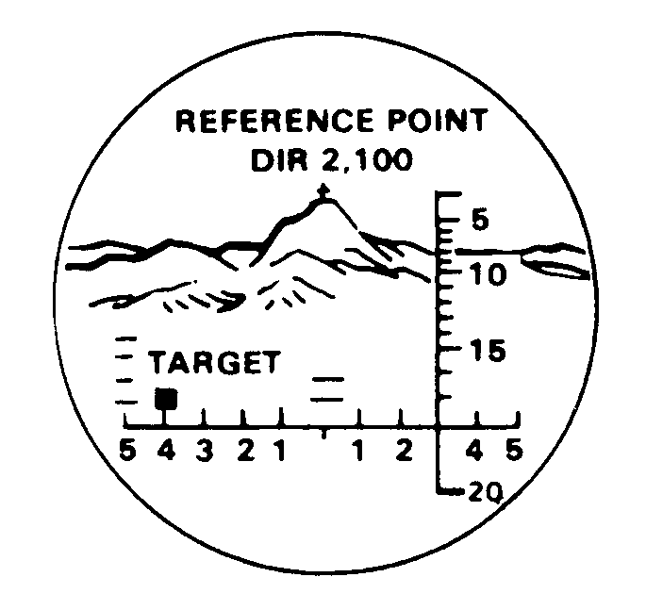
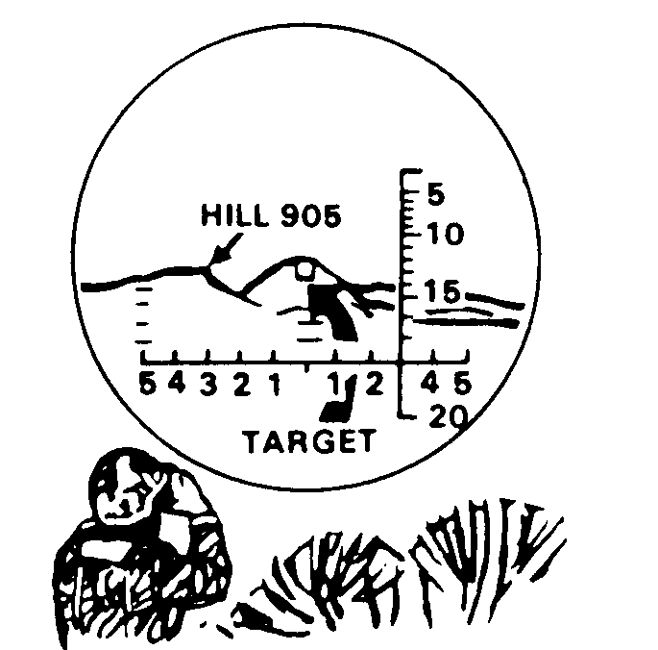

Figure 1. Figure 2.

(2) By the hand-and-finger method:
(a) If you do not have binoculars, you can use your hand and fingers to measure how many mils right or left of the known point the target is. One finger is about 30 mils; two fingers, 70 mils; and three fingers, 100 mils. (See Figure 3 for approximate hand-and-finger values.) To use this method, extend your arm fully and count the number of fingers it takes to cover the distance from the known point to the target. Then, again referring to Figure 3, you have a good estimate of the deviation.

Using the same known point, Hill 905, and the same target, use fingers to measure the deviation (Figure 4). Extending the arm fully and raising a finger, you find that the target is one finger to the right of Hill 905. Recall that one finger is about 30 mils.

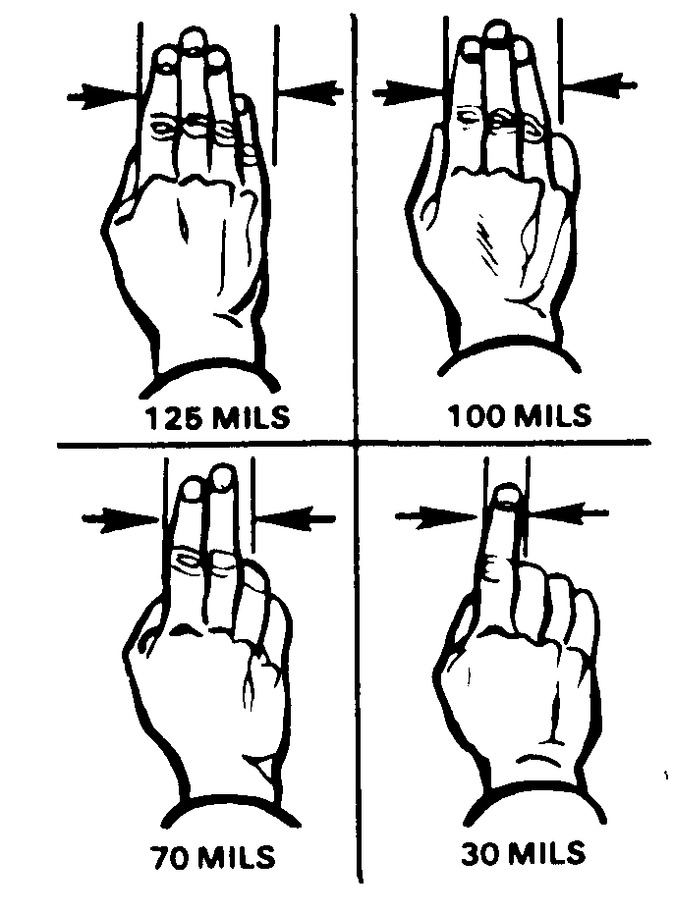

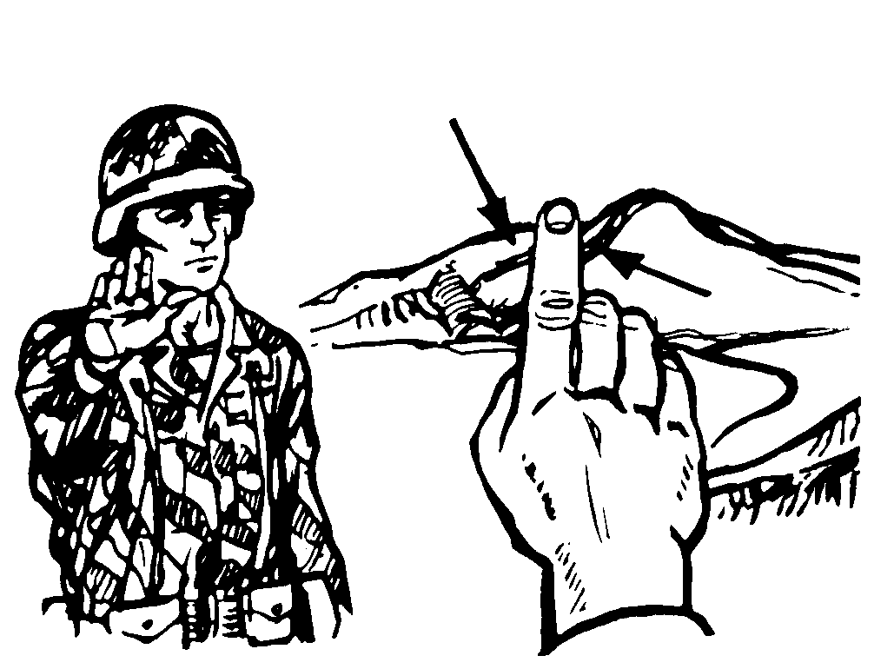
HILL 905
TARGET

Figure 3. Figure 4.

(b) If your measurements are made in degrees, remember that 17.8 mils equals 1 degree. As a general guideline, you can equate mils and degrees by using the relationship, 35 mils equals 2 degrees. The field artillery and mortars, however, prefer measurements in mils. If it becomes necessary to use degrees, be sure you tell the FDC. Remember, your compass will measure mils as well as degrees.
b. Applying deviation. Apply the measured deviation to the known direction. If the target is right of the known point, add the deviation; if the target is left of the known point, subtract the deviation.

Note: An easy way to remember this is the RALS rule: right—ADD, left—SUBTRACT.

(1) Right deviations—ADD. In Figure 2, the direction to Hill 905 is 3200 mils. With the binoculars, measure the deviation (30 mils). Since the target is right of the known point, add the deviation (30 mils) to the known direction (3200 mils). The sum (3230 mils) is the direction to the target.

3200 (direction to known point)
+ 30 (right deviation—add)
3230

(2) Left deviations—SUBTRACT. In Figure 1, the direction to the reference point is 2100 mils. With the binoculars, measure the deviation (40 mils). Since the target is left of the known point, subtract the deviation (40 mils) from the known direction (2100 mils). The answer (2060 mils) is the direction to the target.

2100 (direction to known point)
− 40 (left deviation—subtract)
2060 (direction to the target)

3. Determine the lateral shift from a known point to the target (Figure 5) using the mil-relation formula.
a. The formula is expressed as W/Rm = 1, where m is the angular measurement in mils between the two points, R is the distance in thousands of meters (expressed to the nearest 100) to the known point from which the angle m was measured (Figure 5), and W is the lateral distance in meters.
b. A convenient way of using the mil-relation formula is to cover the W and perform the calculation, Rm, to find the lateral shift in meters. The range (R) is multiplied by the angular measurement (m).
(1) For our purposes, the mil-relation formula is used in conjunction with the distance to the known point expressed in thousands (to the nearest 100) to determine lateral shift. The lateral shift in meters (W) is equal to the distance to the known point (R) times the angular deviation in mils (m).
(2) The distance to the known point is the distance from the observer to the known point (to the nearest 100 meters) divided by 1,000. For example, if the distance to the known point (the church in Figure 5) is estimated to be 3,200 meters, the distance to the known point is 3.2.

3,200 = 3.2
1,000

(3) Now you are ready to determine the lateral shift. Multiply the distance to the known point (3.2) by the angular deviation (30 mils); the product is the lateral shift (96 meters).

3.2 (R)
x 30 (m)
96 (lateral shift) R 100 (W)

Since the deviation is to the right, shift right 100. (Deviation is expressed to the nearest 10 meters.)

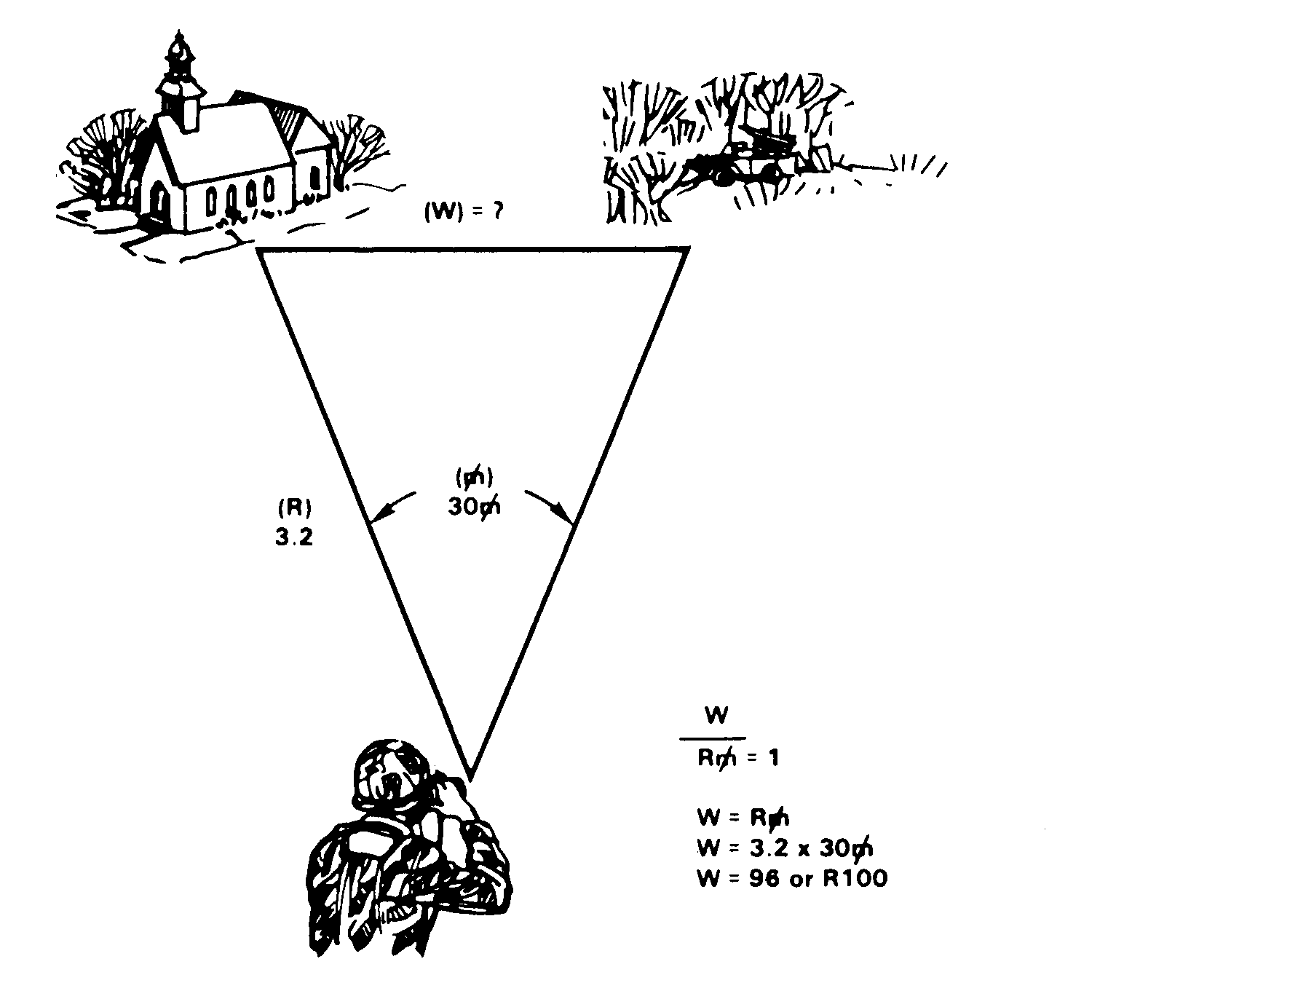
KNOWN POINT
TARGET
3,900 METERS
TO TARGET
MIL RELATION
OBSERVER

Figure 5.

4. Determine range change from the known point to the target (Figure 5).
a. The range change is estimated to the nearest 100 meters. If the target is beyond the known point, we add the range difference. If the target is closer than the known point, we drop the range difference.
b. For example, if the distance to the known point is 3,200 meters and the estimated distance to the target is 3,900 meters, the range change is 700 meters (3,900 − 3,200 = 700). Since the target is beyond the known point, we add 700. If the target distance is estimated at 2,800 meters, the range change is 400 meters (3,200 − 2,800 = 400). Since the target is closer than the known point, we drop 400.

Note: The task, Determine Azimuths Using a Protractor and Compute Back Azimuth, must be mastered as a prerequisite to this task.

EVALUATION PREPARATION

Setup: Ensure that a target is readily identifiable to the soldier and the equipment listed in the conditions statement is present and operational. The evaluator must know the grid location, direction, and distance to the target that will be used.

Brief Soldier: Identify the target to the soldier. Tell the soldier to determine the location of the target within 30 seconds.

Note: Ensure that the tested soldier understands exactly what is expected of him, but do not help him in any way.

EVALUATION GUIDE

Note: Scorer must identify the known point and the target for the soldier

Performance Measures Results
(Sequence is not scored.)

1. Determine the observer-target direction within + 100 mils
of the actual direction, expressed to the nearest 10 mils. P F

2. Determine and announce the lateral shift from the known
point to the target to the nearest 10 meters. P F

3. Determine and announce the range change from the known
point to the target to the nearest 100 meters. P F

4. Determine and announce the vertical shift (up or down)
from the target to the known point. Unless there is an obvious
difference, ignore the vertical shift. P F

Performance Measures Results

5. Complete steps 1 through 4 within 30 seconds. P F

FEEDBACK

Score the soldier GO if all steps are passed. Score the soldier NO-GO if any steps are failed. If the soldier fails any steps, show what was done wrong and how to do it correctly.

REFERENCES

Required Related
None FM 6-30

